

Submitted in partial fulfilment of the requirements for the award of degree of

BACHELOR OF COMPUTER APPLICATION

Submitted By: Sarvesh Singh(19BCA1314)

Divyanshi(19BCA1398) Tanvi Sood(19BCA1271)

# Food Ordering Management System

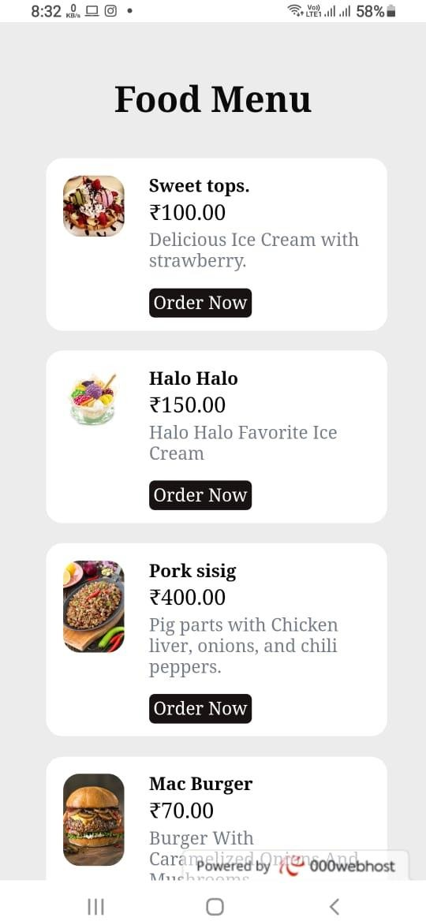

**Fotod This a**

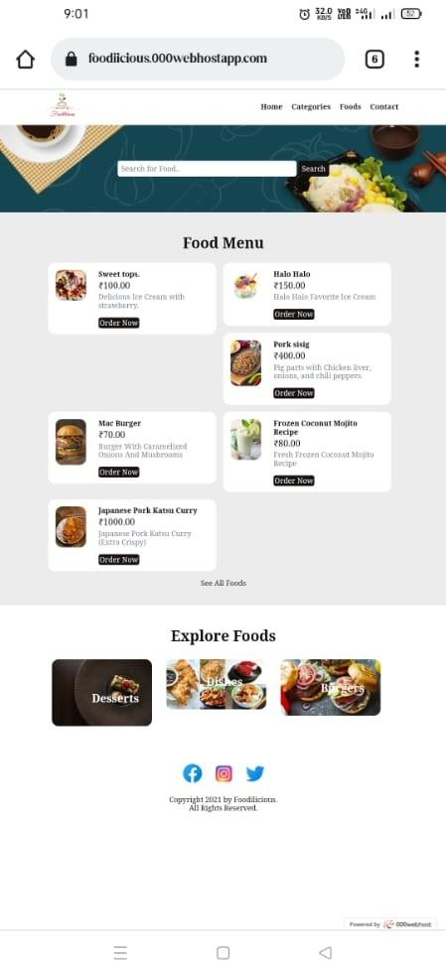**This a view in Mobile**

This is view of Tablet





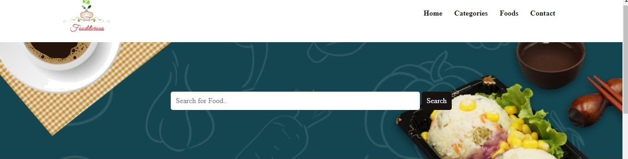

Food ñlenu

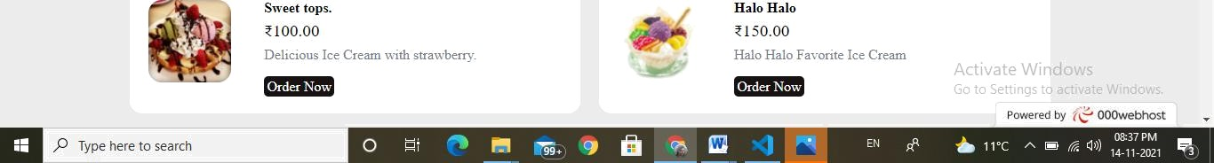

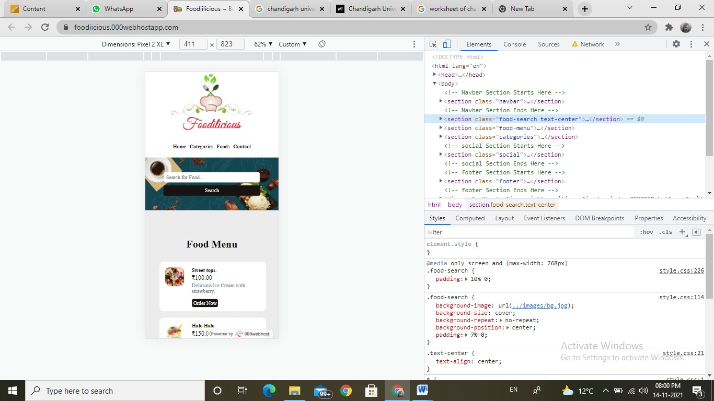

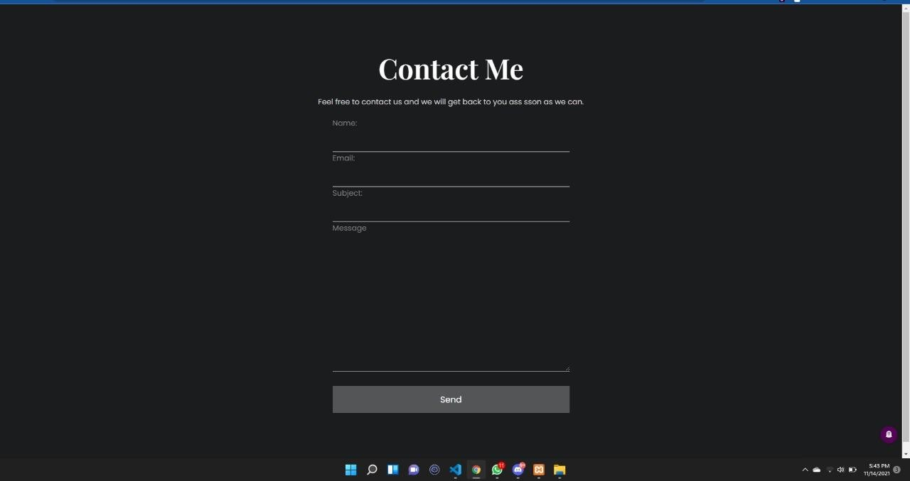

This a form to fill details for feedback.

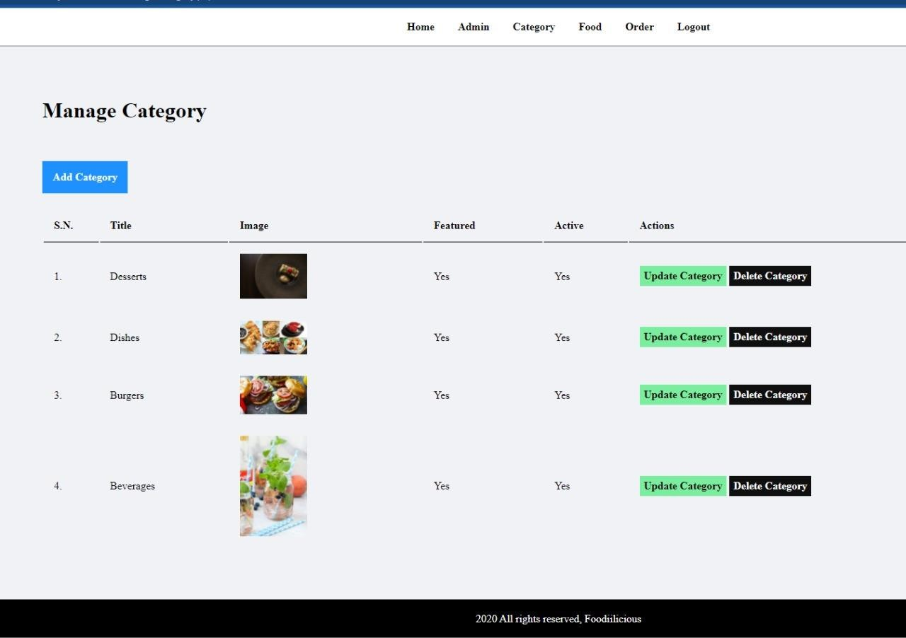

 

Update Food

Title:



Description:



Current Image:

Select New Image

100.00



hCosFe No file chosen

Category: Desserts ••r

Featured: R Yes O No

Active: R Yes O No

